STEPS TO REGISTER AND FILL THE ONLINE APPLICATION

Step 1: Once you click on the link GDCE ONLINE APPLICATION you will see this page where you have to confirm whether you meet the following criteria.
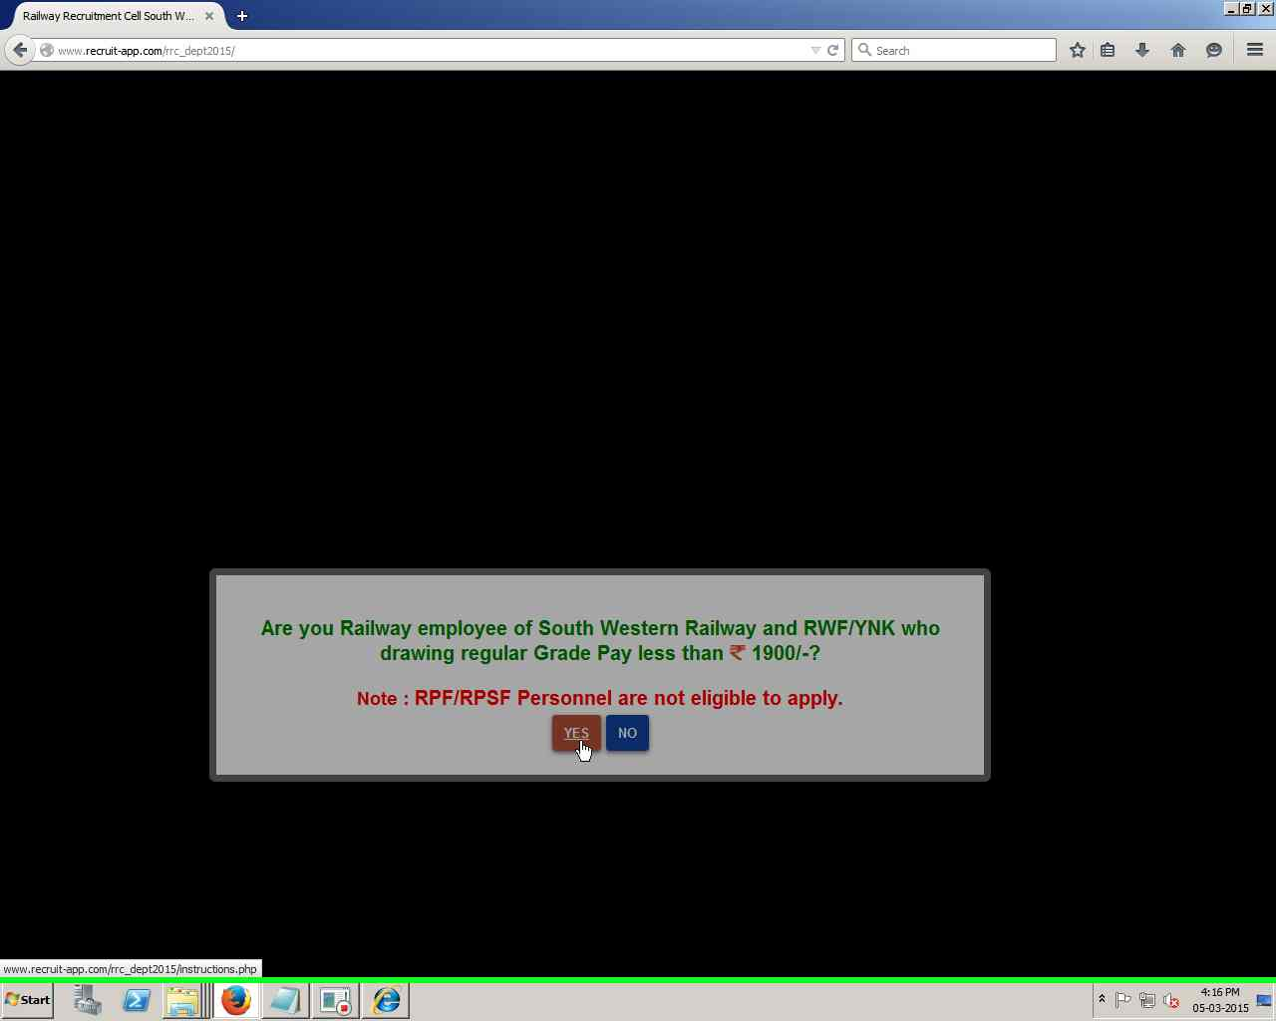

Step 2: After confirming that you are the right employee, Click on “Notification & Instructions” to read all the eligibility criteria’s and other instructions. After that click on “steps to be followed to Register and fill the online application” and finally after going through all the information thoroughly, click on “I Accept & Agree” to proceed.
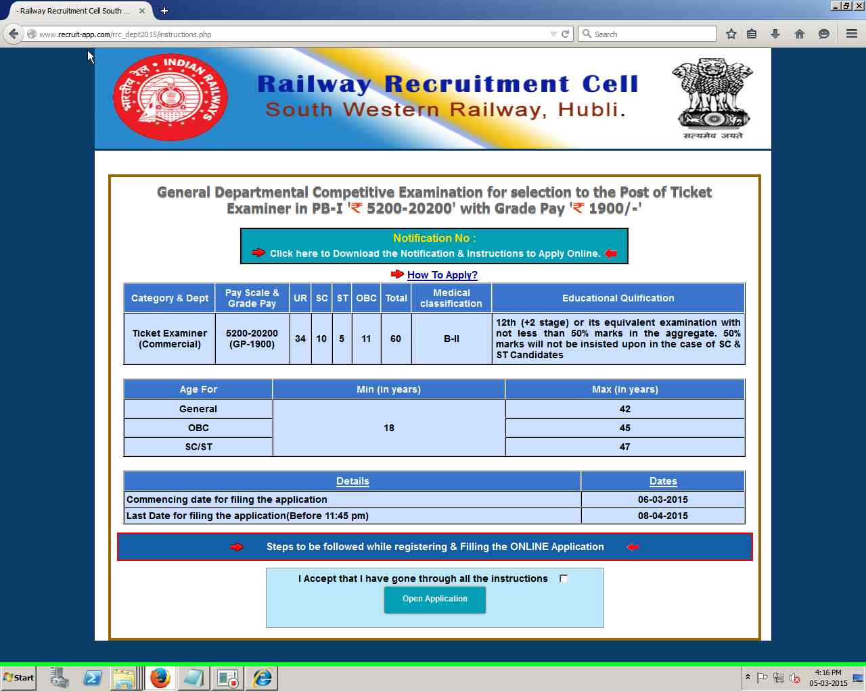

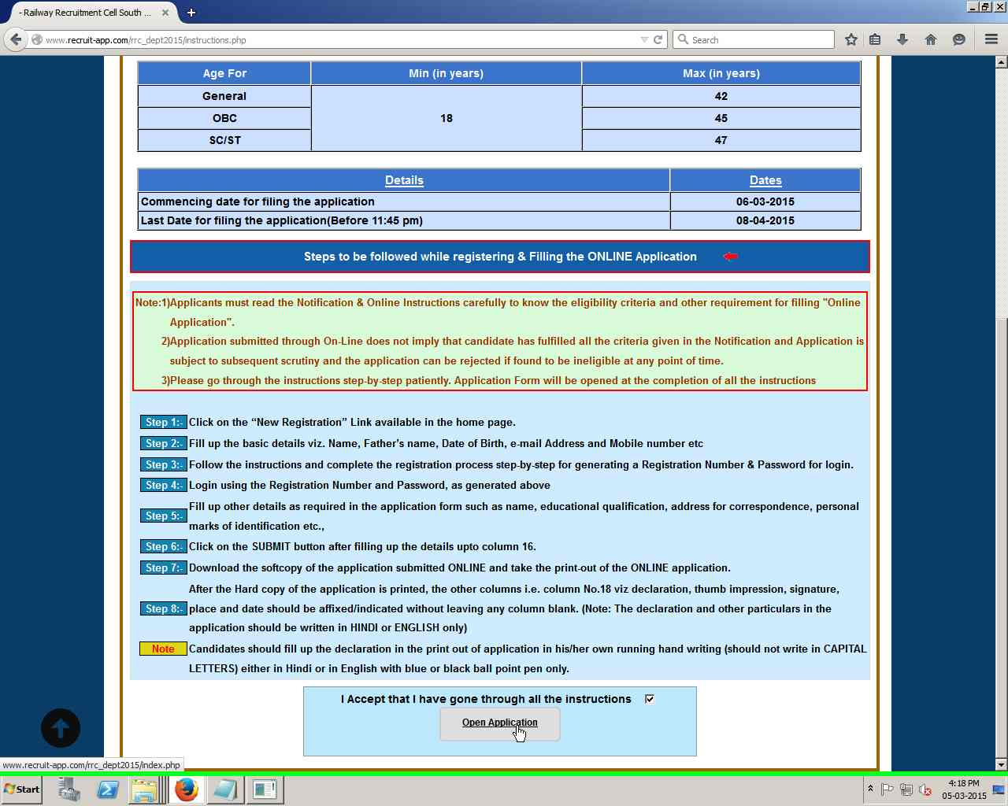

Step 3: If you don’t have Registration Id and Password then click on “Click Here For New Registration” fill all the details in registration and submit
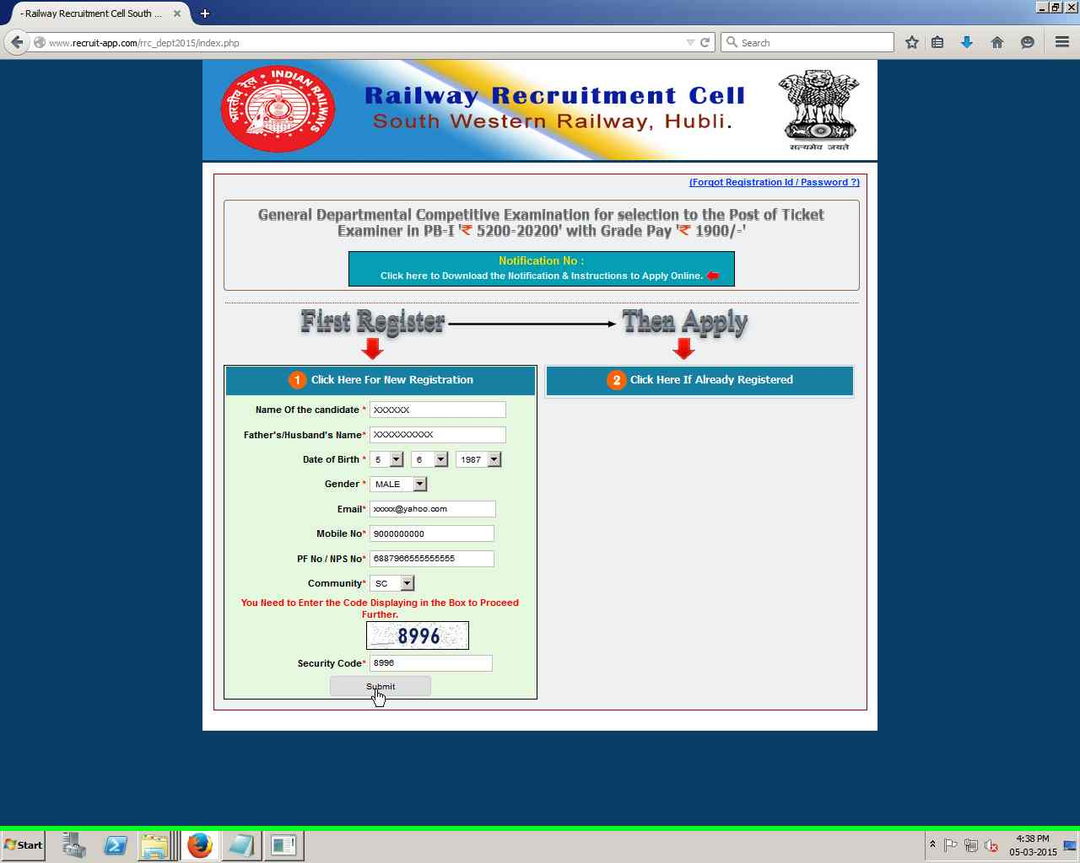

Step 4: Verify the information which you have registered. If you want to edit click on ‘EDIT’ button, else click on ‘Confirm’ Button to proceed.
Note:- Once you submit, you cannot edit your personal details.
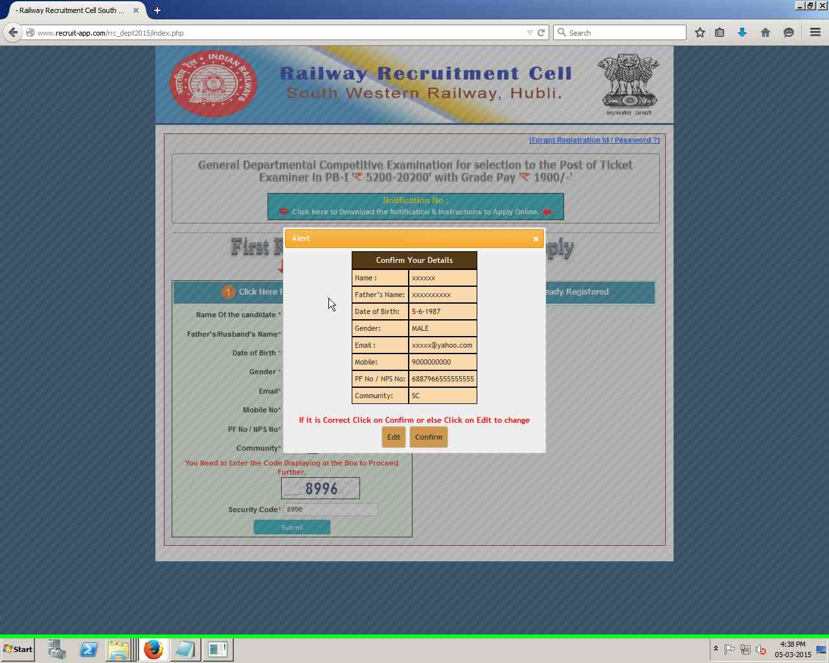

Step 5: Note down your Registration Id and Password for filling your application & for future reference. This information will also be sent to your Registered Mobile No & Email via SMS and Email respectively.
Note:- You can proceed to filling your application by clicking on “Click here to fill your application”.
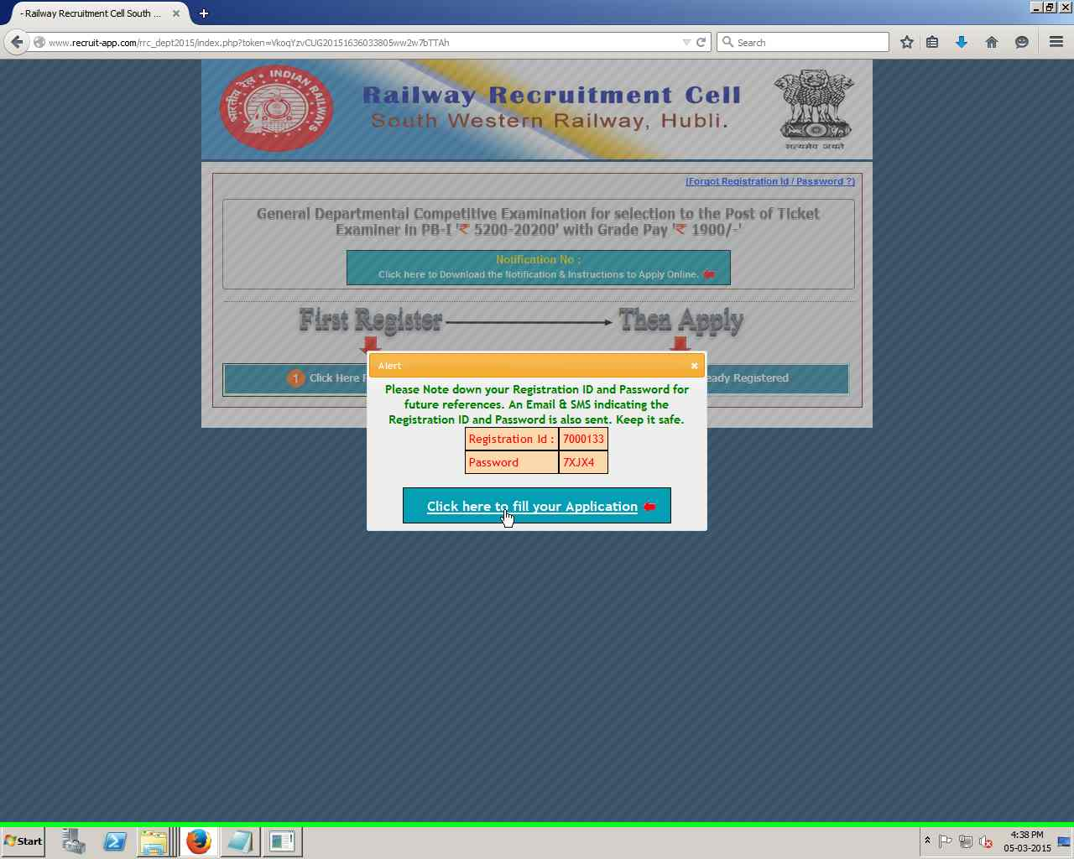

Step 6: You can also login with your Registration ID and Password (If already Registered)to fill, to edit or to take a printout of your filled application at any point of time.
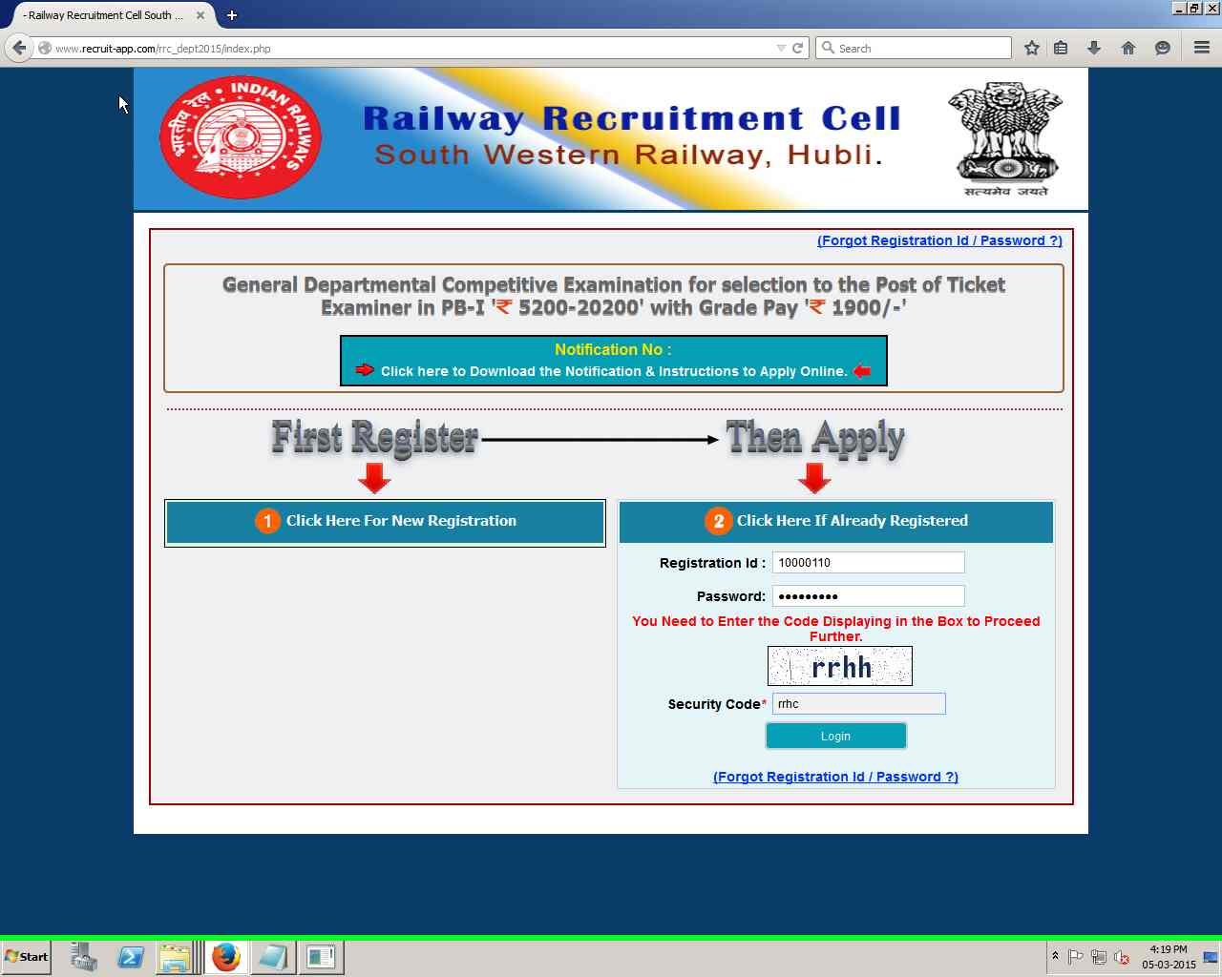

Step 7: Fill all the Mandatory details in the application as directed. You can also save your application at any point of time if you want to continue later. After filling the complete application and submit your application, the “Print Application” Button is enabled automatically. If you want to fill the application later you should click on Save Draft and logout to this page.

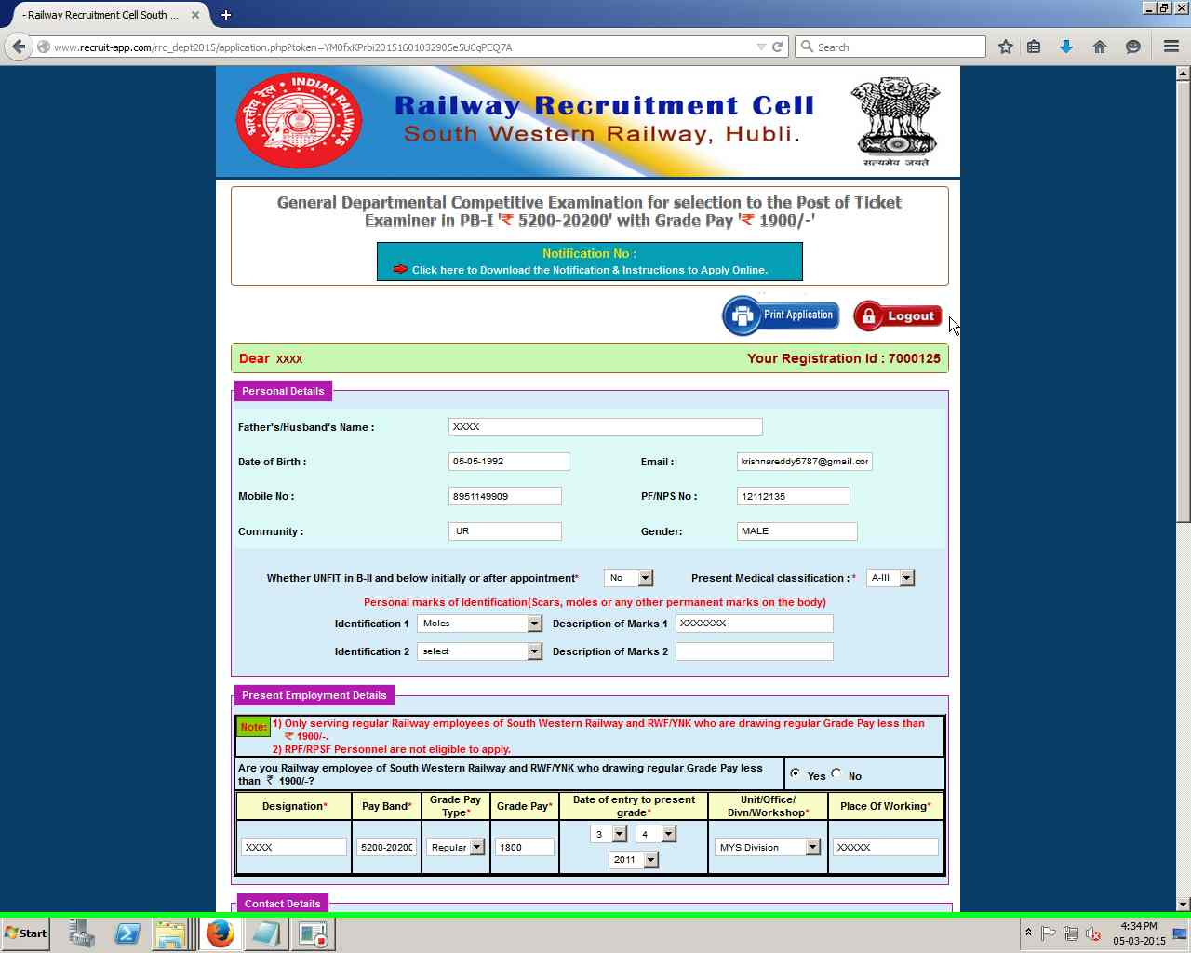
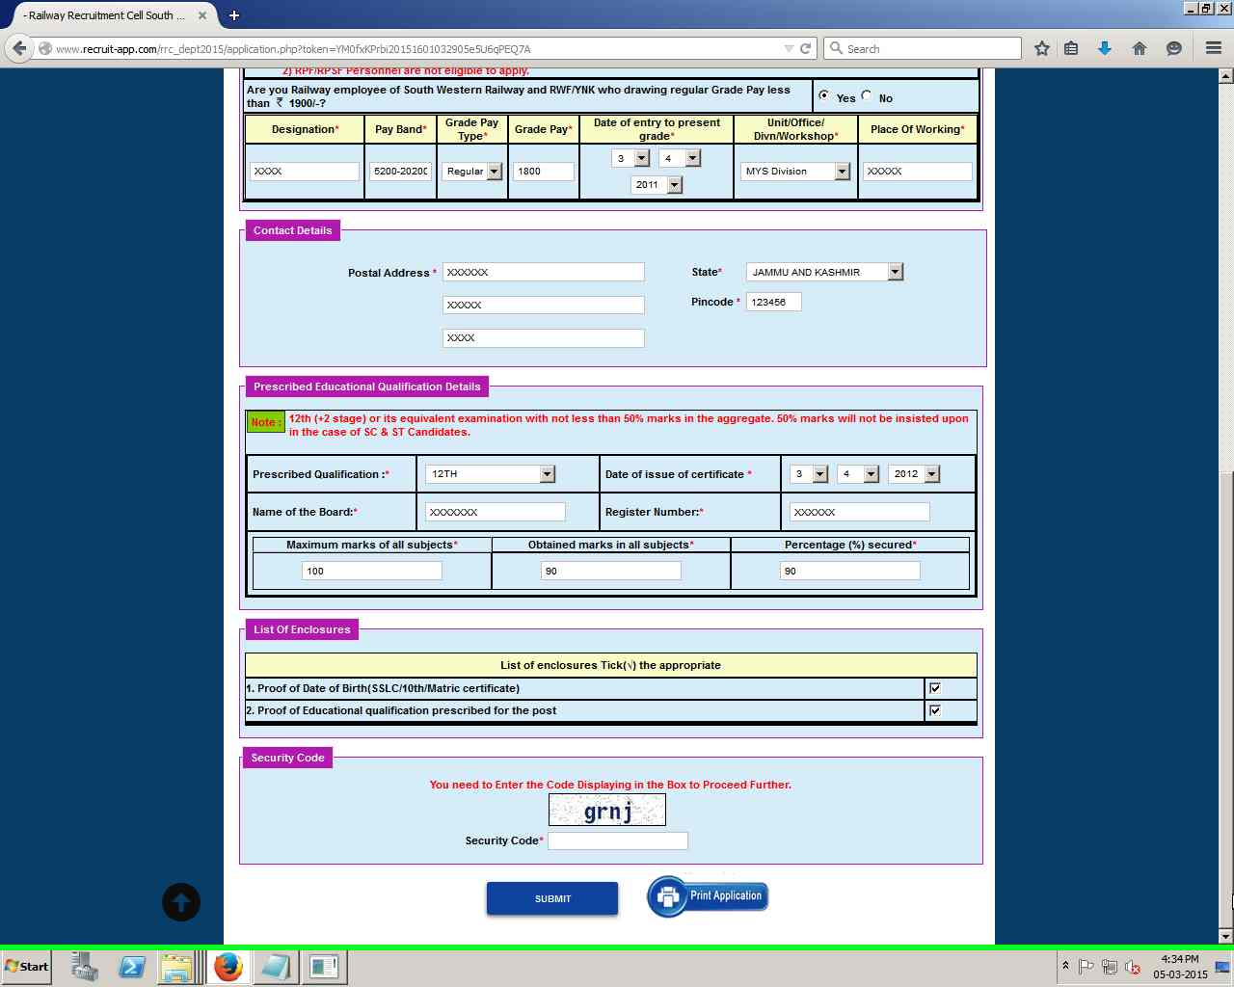
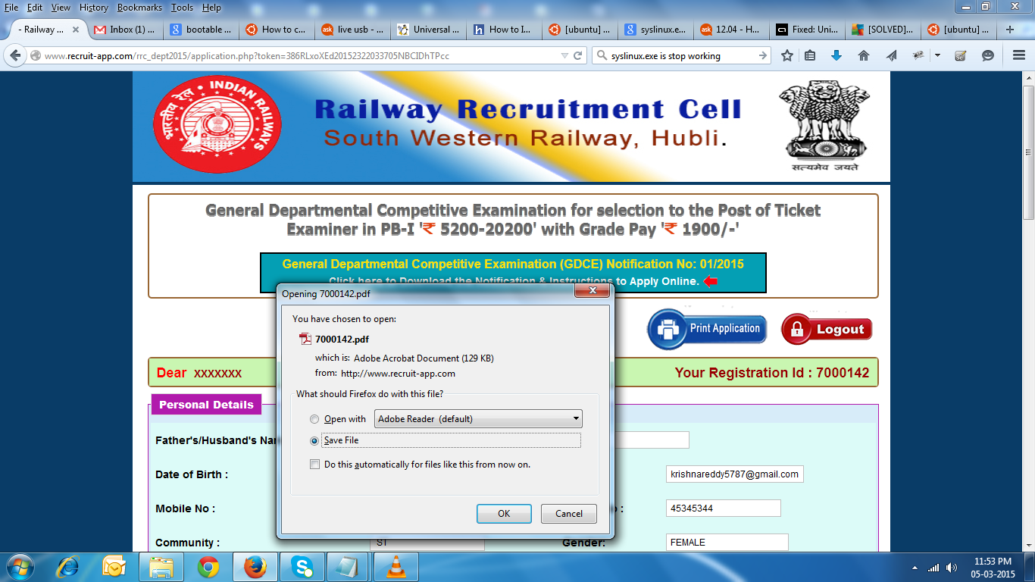

Step 8 : After the Hard copy of the application is printed, the other columns i.e. column No.18 viz declaration, thumb impression, signature, place and date should be affixed/indicated without leaving any column blank. (Note: The declaration and other particulars in the application should be written in HINDI or ENGLISH only).
Note : Candidates should fill up the declaration in the print out of application in his/her own running hand writing (should not write in CAPITAL LETTERS) either in Hindi or in English with blue or black ball point pen only.
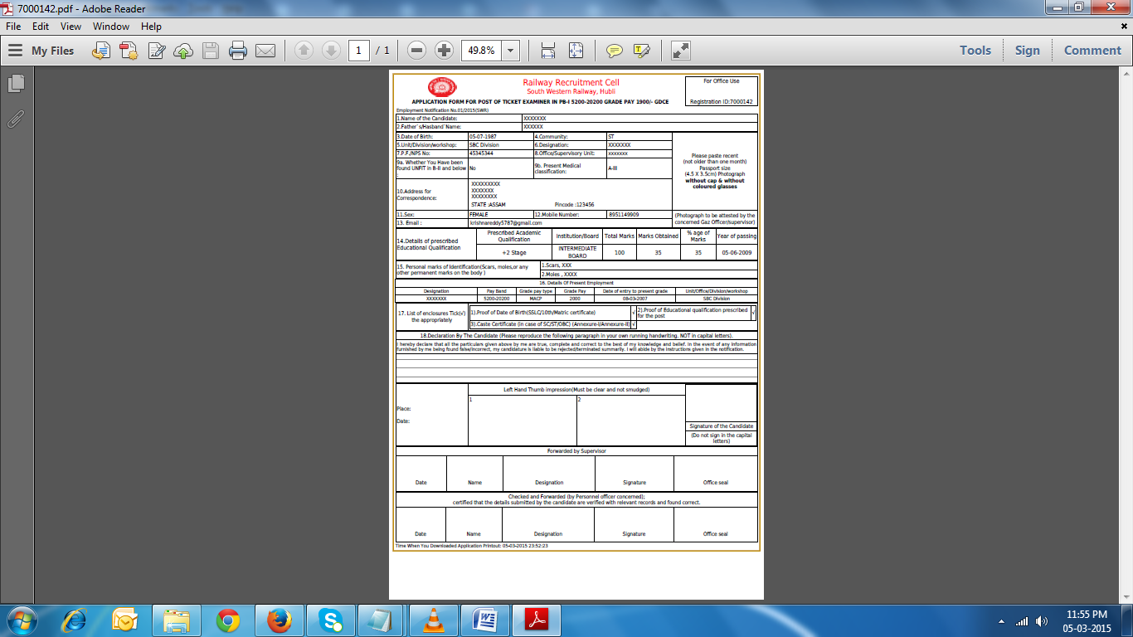
FORGOT REGISTRATION ID / PASSWORD

Step 1 : Click on Registration ID / Password if you want to retrieve your Registration Id/Password. Enter your Mobile No, Email Id & PF/NPS No and click on confirm.
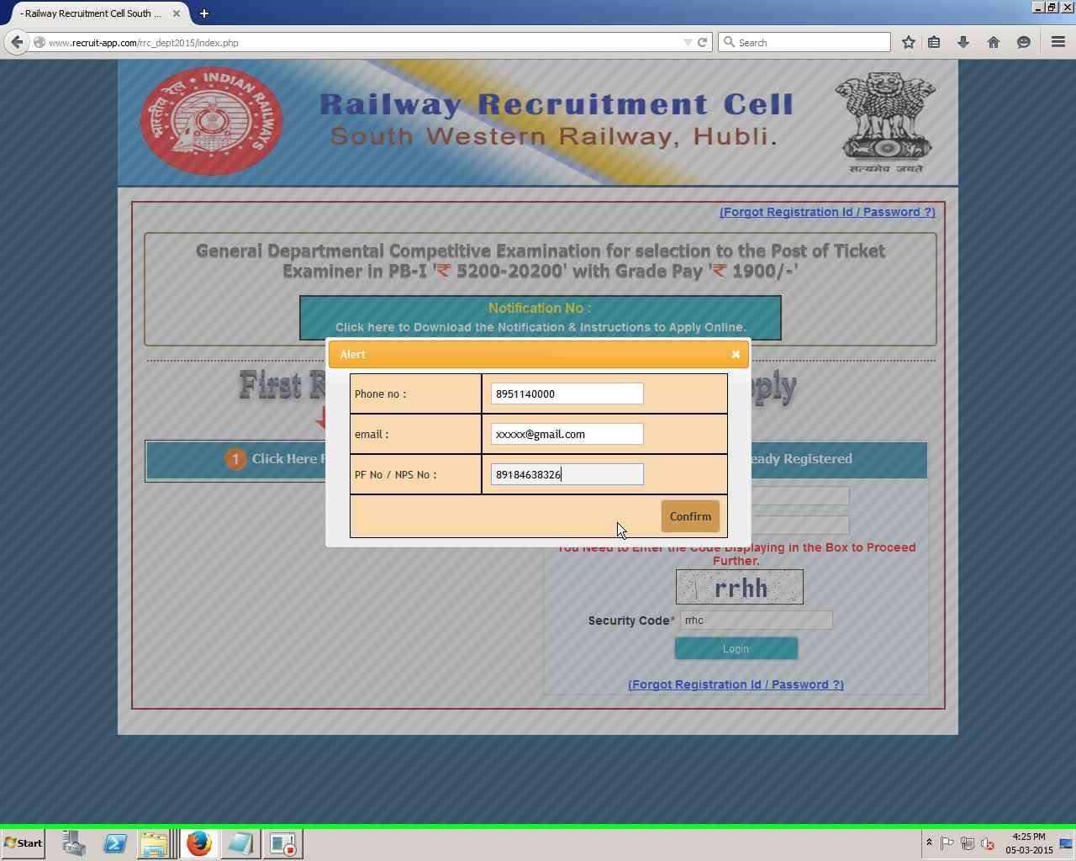

Step 2 : If your entered details matches, the Registration Id & Password will be displayed on the screen. Please make a note of it & keep it safe for future references.
